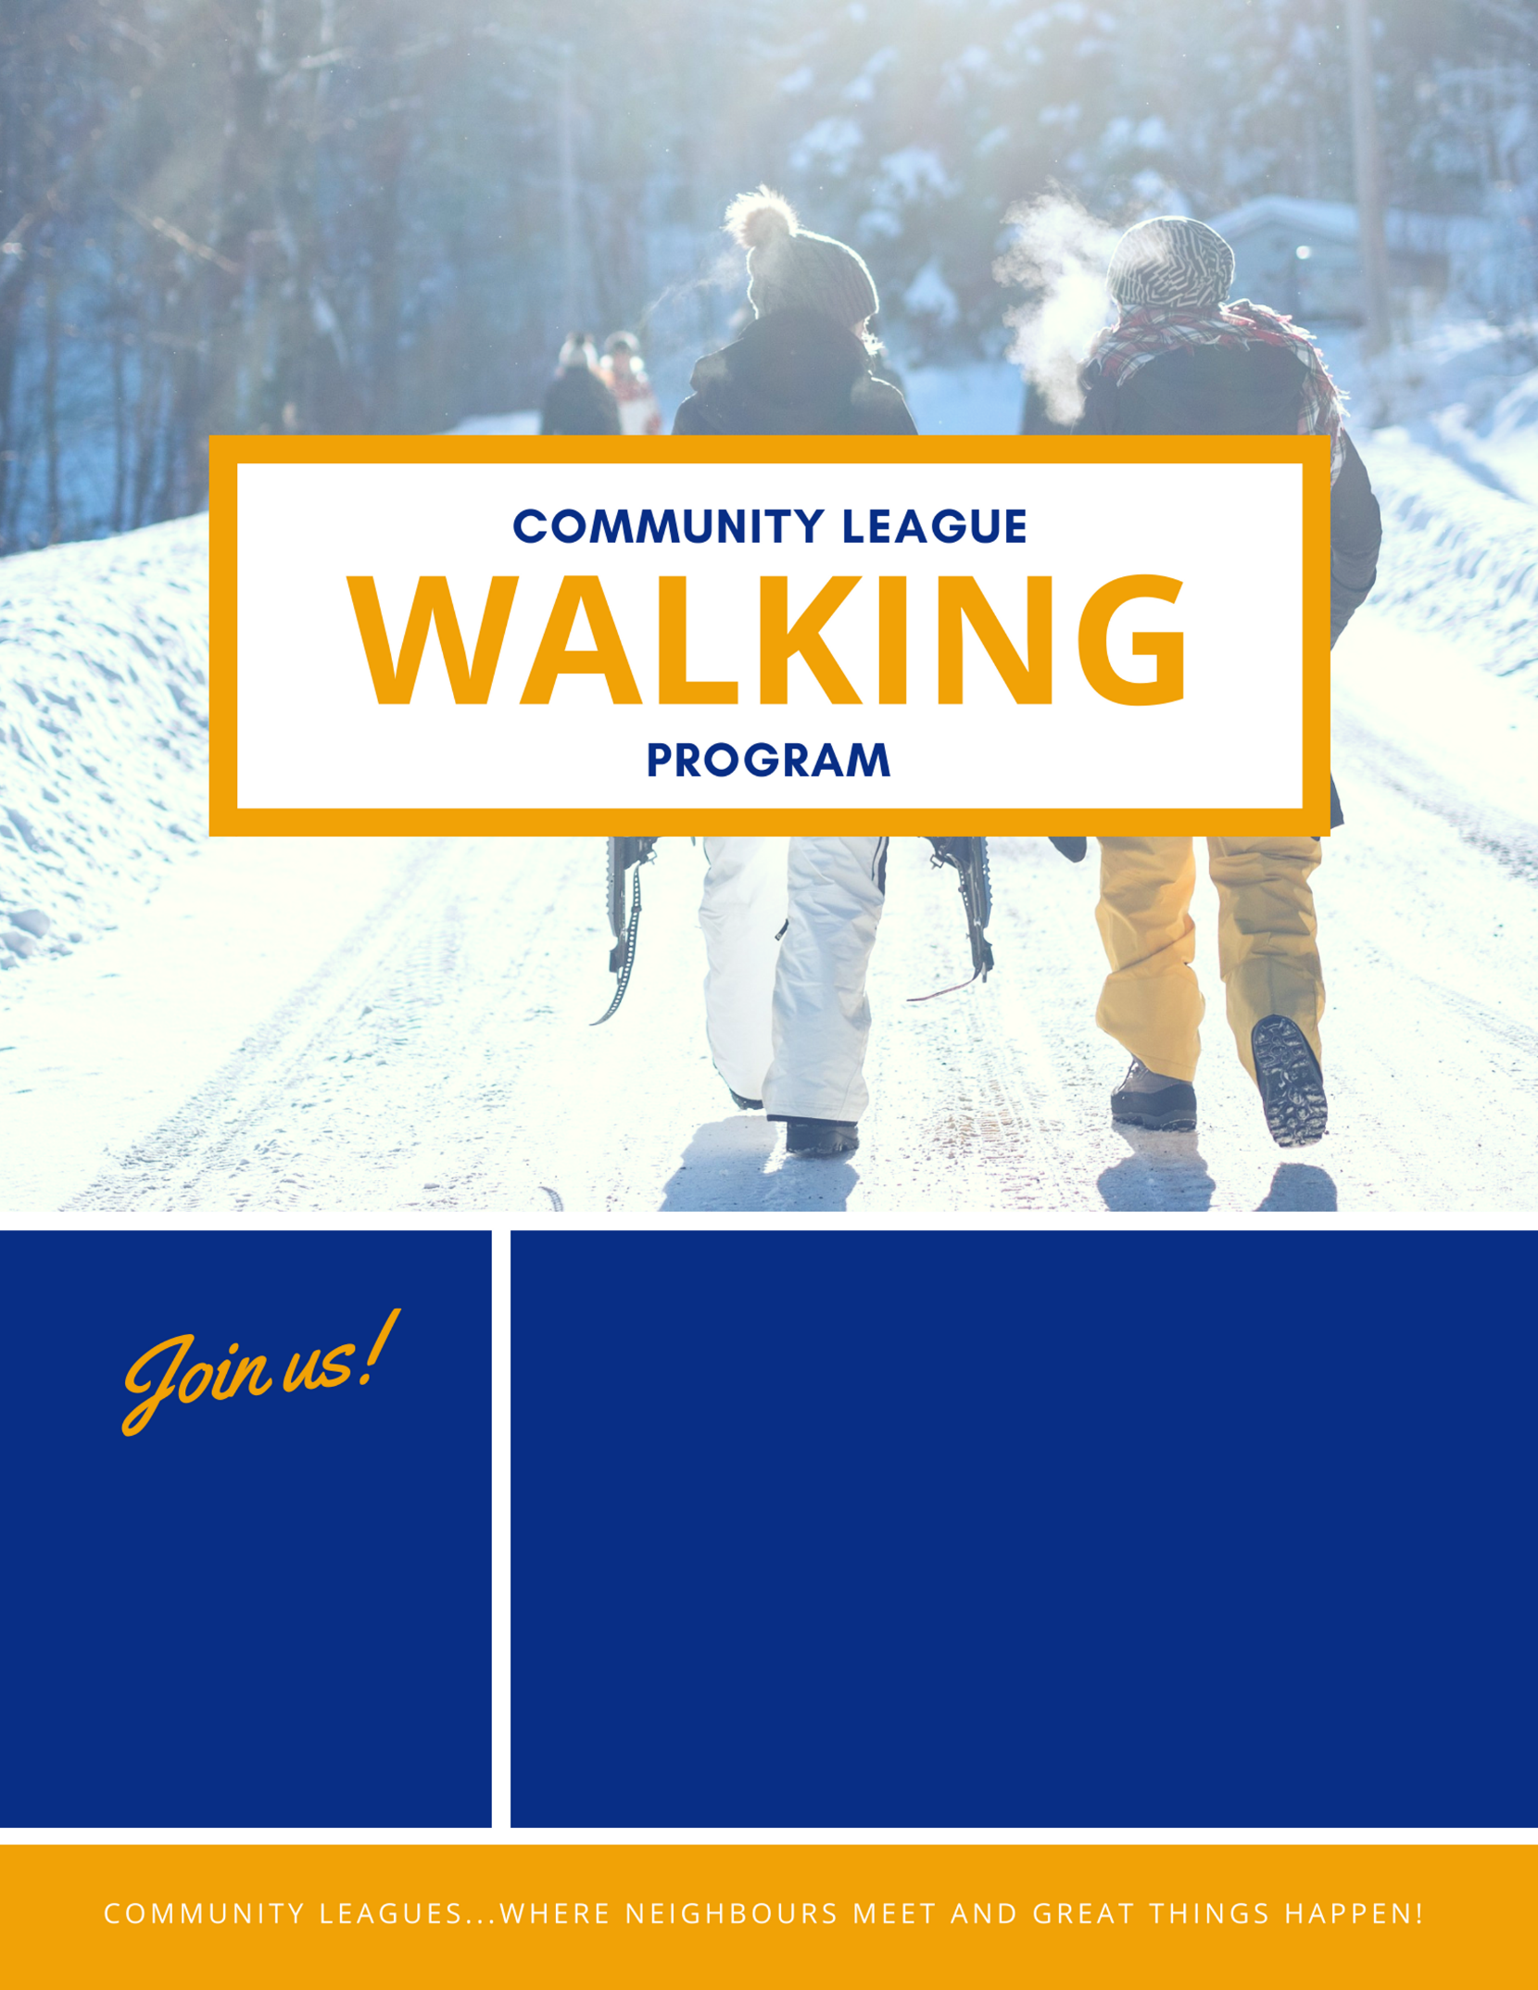
WALK YOURSELF TO A HEALTHIER, HAPPIER YOU!
- Urban poles will be provided to members on a first come first served basis.
- Walking sessions will be cancelled if the temperature is below -20 C.
- Open to all community league members.
For more information, contact info@efcl.org

WEDNESDAYS
9-10 AM
STARTING
NOVEMBER 7, 2018

